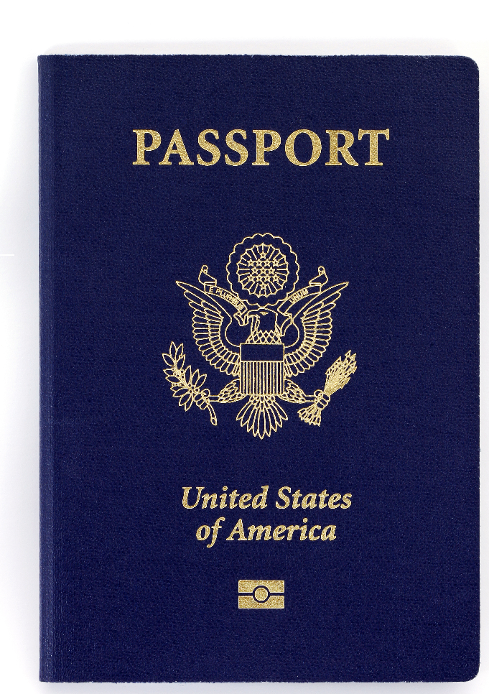

Discounted Visa & Passport Processing Fees for Direct Travel Clients… Savings from 30 – 60%!
Many of our clients regularly take advantage of the deeply discounted processing fees and expedited services offered through CIBTvisas – Direct Travel’s preferred provider of Visa & Passport services, and the leading provider of these services worldwide.
If your employees require assistance with any Visa or Passport services, we encourage them to contact CIBT through the Direct Travel program which extends significantly reduced CIBT service fees (30 – 60% off CIBT’s retail rates).
To take advantage of the preferred Direct Travel/CIBT program, please contact CIBT at:
- CIBT website for travelers living in the US: www.cibtvisas.com/dt
- Toll free: 888-487-7058 Callers must reference our CIBT account number 40801
- Travelers who live outside of the US can verify requirements at http://dt.cibtvisas.com
At Direct Travel, our goal is to consistently provide you with valuable tools that support your travelers’ needs and present value at the same time. I know that our partnership with CIBT will accomplish both of these objectives.
If you have any questions about the CIBT program or would like to learn more about CIBT services, please let us know.
More About CIBTvisas
- Complete jurisdictional coverage
- Toll free support, Monday through Friday, from 8:30 a.m. – 9:00 p.m. Eastern
- Impeccable service, personalized attention

